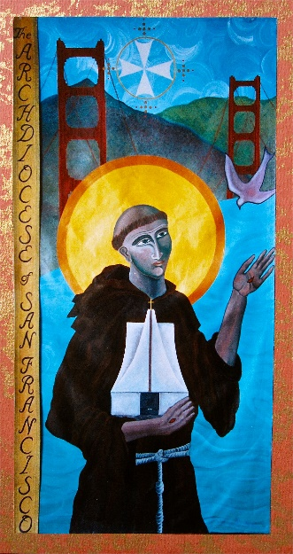
Basic & Master Catechist Credit for
Office of Faith Formation Conference 2023
One hour per workshop

“Catechists are selected and commissioned “to proclaim Christ’s message, to participate in efforts to develop community, to lead people to worship and prayer, and to motivate them to serve others” (NDC #213). When commissioned, the Catechist recognizes the faith community’s call and his/her dedicated response.
While catechist must realize “that faith is a gift and it is not ultimately their effort…which lea people to accept faith and respond to it,” catechist should acquire the particular knowledge and skills that they need to assist adults, young people, and children, including those with special needs, to grow in faith. (CCC Guidelines for Obtaining the California Catechist Certificate or California Master Catechist Certificate. Pg.2)
This conference gives credit in the various areas of formation to obtain or renew a certificate. This is an ideal place to come together and be formed by nationally known expert presenters of the faith. All catechists are expected to gather for this important training.
Catechists are asked to keep a record of their attendance and other workshops to complete certification, Renewal of certification requires 10 hours of in-service every year. The certificate is good for 3 years. Please check with your Parish Catechetical Leader for more details.

Title | Workshop Time | Speaker | Credit given in these areas

