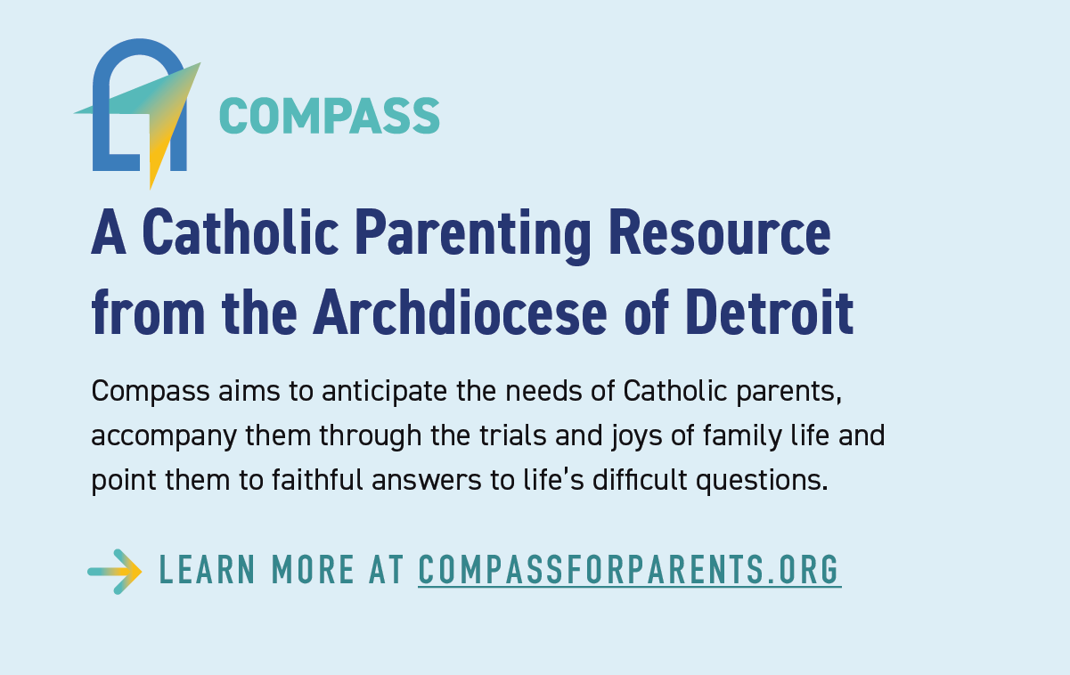

Compass is a wonderful new resource for parents (and catechists), addressing topics of concern to young people today.
- Go to the Compass website (above)
- Select the topic of interest from the menu
- You will get a brief description – click on “read more”
- You will then get
    - A brief description of potential difficulties to anticipate
    - Some suggestions for ways to accompany your young person
    - A great set of resources to help provide answers. to address the particular topic, resource which are current, and vetted by a faithful Catholic psychologist.
To date this resource is only in English – we anticipate it will be in Spanish by next spring

