
Teen STAR

What is Teen STAR?
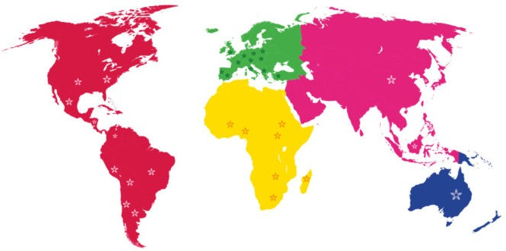
Teen STAR is a sexuality and affectivity educational program that accompanies children, adolescents, and young adults, appropriate to their physical and psychosocial stages of development. Teen STAR addresses all aspects of the human person.

Over 50 countries

have implemented Teen STAR since 1980 in diverse settings by addressing all aspects of the human person: the Physical, Intellectual, Emotional, Spiritual, and Social, utilizing an attractive educational approach.

Building Bridges
between Adolescents and their Parents
Instructors lead parent meetings that equip and empower parents to accompany their children through the different stages of their development using a holistic approach that strengthens their child’s self-esteem and fosters skills for making good decisions.


Teen STAR Outcomes
- Delay in the initiation of sexual activity.
- Lowered pregnancy rates among adolescents. **
- Better communication between parents, peers, and instructors.

The impact of the Teen STAR Program was evaluated in a prospective, double-blinded, randomized study. Two groups were followed for 4 years: a control group (4.87% and a group that received Teen STAR instruction. Results show a decrease in pregnancy rates in the Teen STAR instructed group (1.01%)


Instructor Training

Teen STAR Instructor Training Sessions are aimed at adults who want to learn to talk about sexuality with their children, high school students, or members of youth and young adult groups. Typically, this includes parents, schoolteachers, youth group leaders, and catechists.
We will offer another in-person training in Archdiocese of SF in the spring of 2024.

Contact Ed Hopfner/hopfnere@sfarch.org or Deacon Santiago Molina (below).

Courses are also offered Online. For information about training instructor training courses, visit our website or contact us.

Curriculum
Outline
--Personalistic model of education
--Child and adolescent development
--The adolescent brain
--Male and female anatomy
--Fertility awareness
--Human love
--Personal Identity
--Sexually transmitted infections --Methods of family planning
--Counseling and Accompaniment

Contact:
Deacon Santiago Molina www.teenstar.org |
850-296-7124
teenstarprogram@gmail.com | Instagram: @teen_star_usa
| Facebook: Teen STAR USA

